**Launching Instances through AWS CLI(Command Line Interface)**

Step -1: Install the AWS CLI in computer

Step -2: Go to the command prompt in windows and follow the below commands

Step -3: To check whether AWS CLI is installed or not in our computer …. Type aws --version

Step -4: After this Create one user for practice use in IAM Credentials , and generate Access key and secret Access key in security credentials.

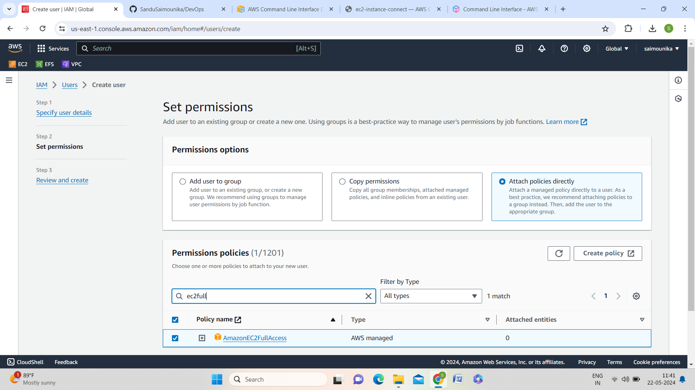

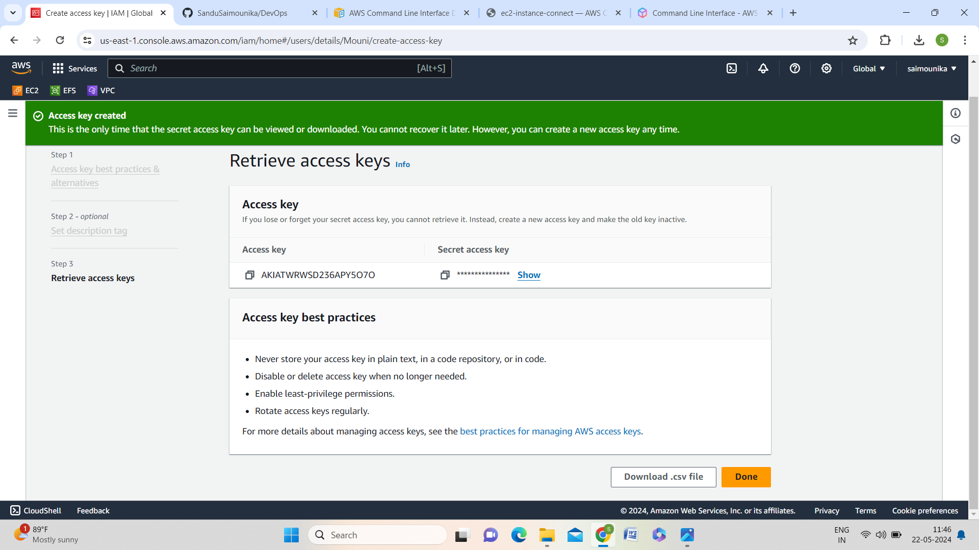

Step -5: after this follow the commands as shown in pictures

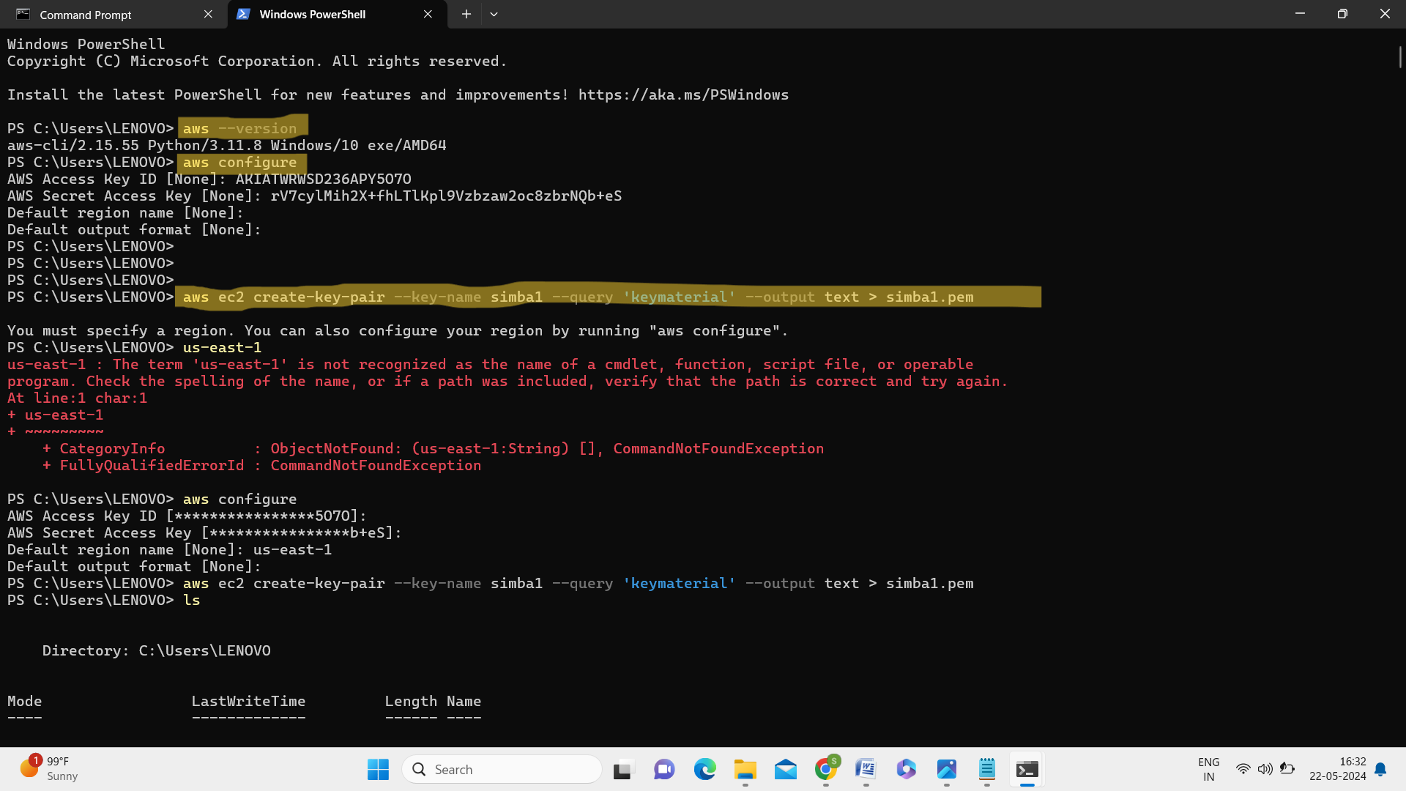

* (aws ec2 create-key-pair --key-name simba1 --query 'keymaterial' --output text > simba1.pem)

1. **aws ec2 create-key-pair**: This is the command to create a new key pair in Amazon EC2. A key pair consists of a public key that AWS stores, and a private key file that you store. Together, they allow you to securely connect to your EC2 instances.
2. **--key-name simba1**: This option specifies the name of the key pair you want to create. In this case, the key pair will be named **simba1**.
3. **--query 'keymaterial'**: This option is used to filter the output of the command. Here, it's used to extract the **KeyMaterial** property from the returned JSON. **KeyMaterial** contains the actual private key.
4. **--output text**: This specifies the output format. By setting it to **text**, the command will output only the raw key material (the private key) without any additional formatting.
5. **> simba1.pem**: This part of the command redirects the output (which is the private key) to a file named **simba1.pem**. The **>** operator is used in shell commands to redirect output to a file.

**Explanation of the Full Command**

When you run this command, AWS CLI will:

* Create a new key pair named **simba1**.
* Extract the private key (**KeyMaterial**) from the response.
* Output the private key in plain text format.
* Save this private key to a file named **simba1.pem**.

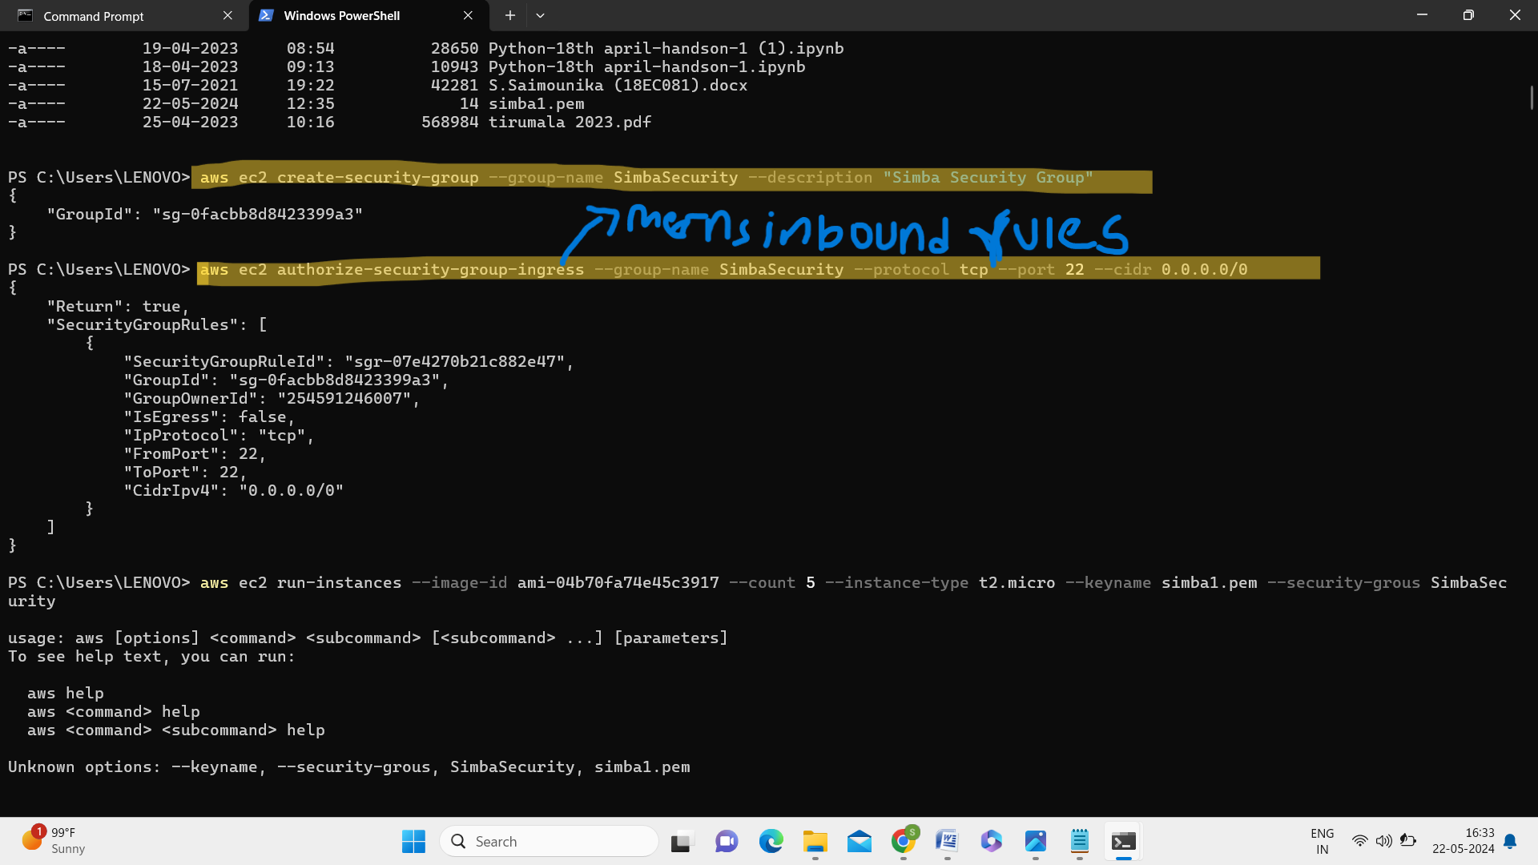

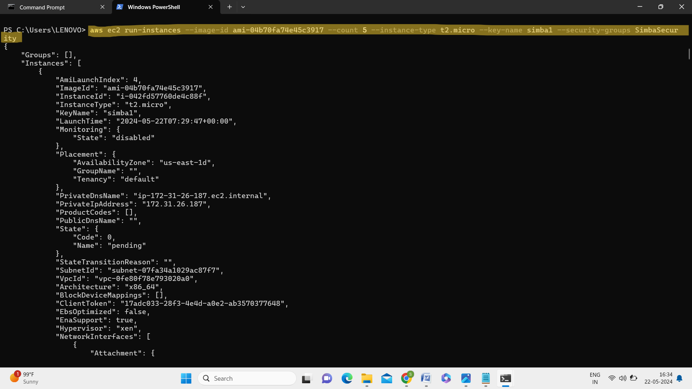

* (aws ec2 run-instances --image-id ami-04b70fa74e45c3917 --count 5 --instance-type t2.micro --keyname simba1.pem --security-groups SimbaSecurity) here in count ‘5’ 5 means number of instances we are willing to launch .

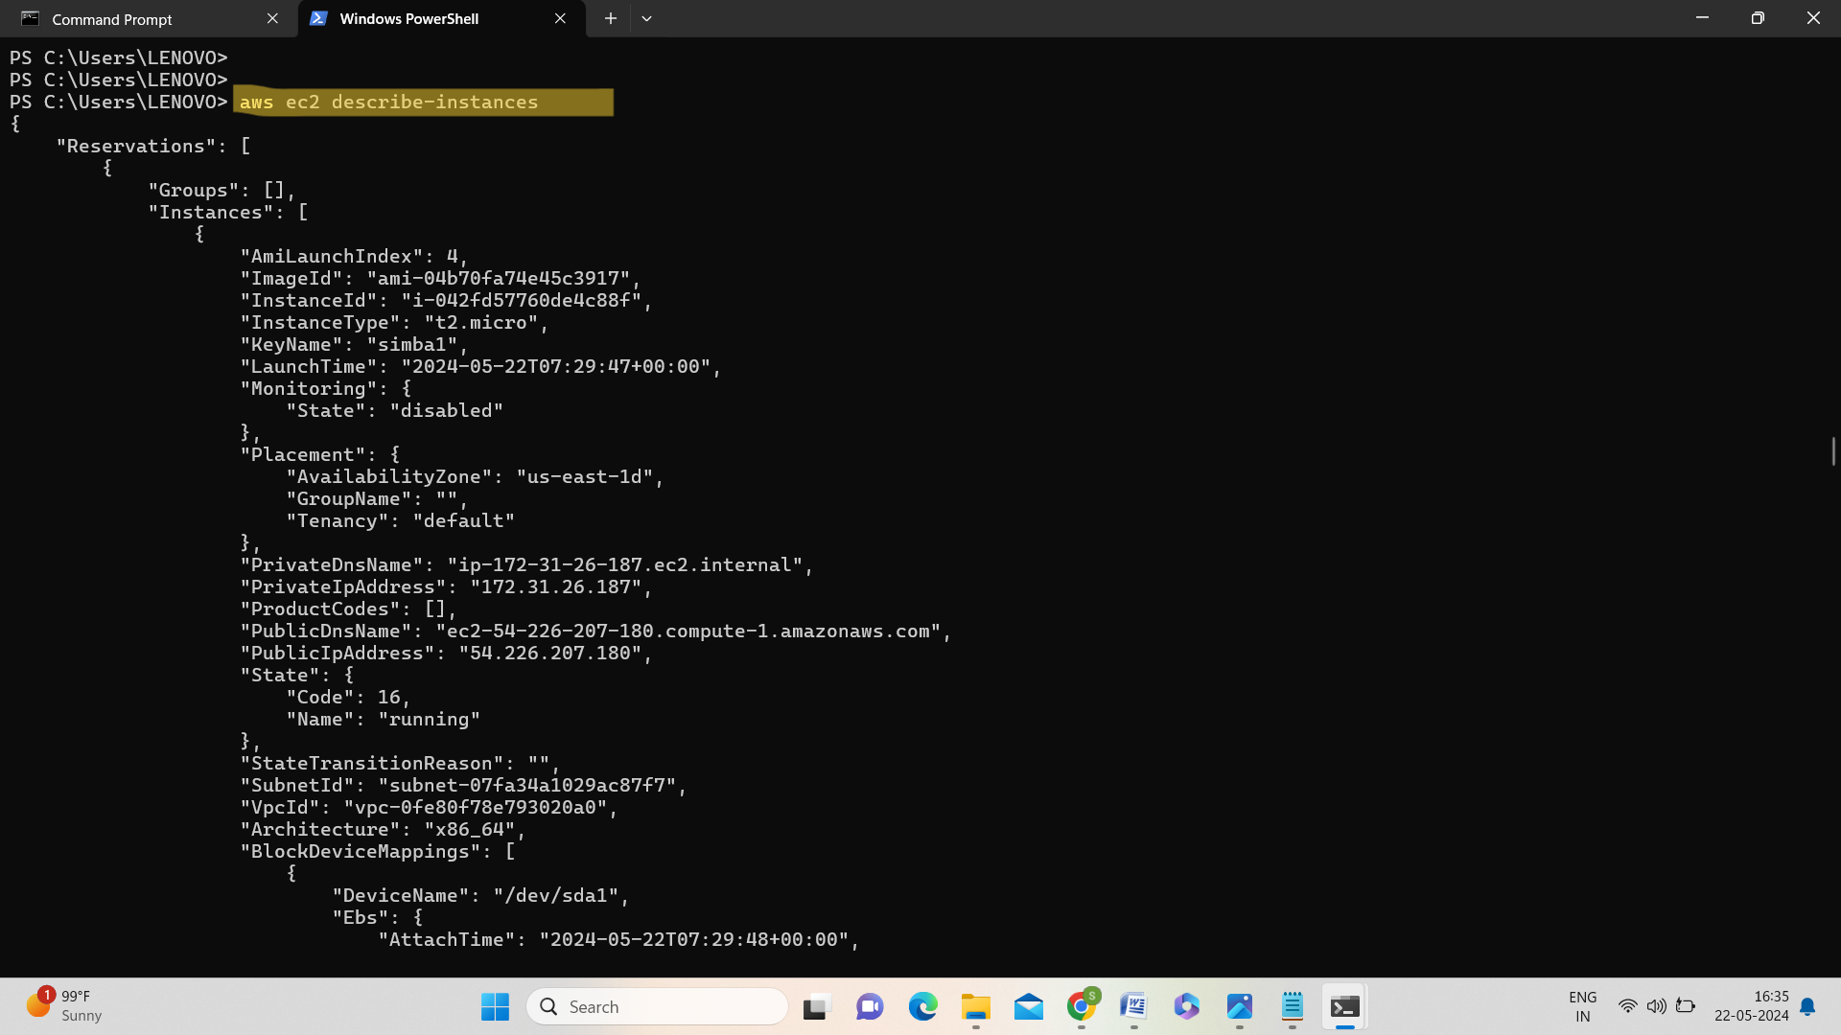

* It gives the list of running instances.

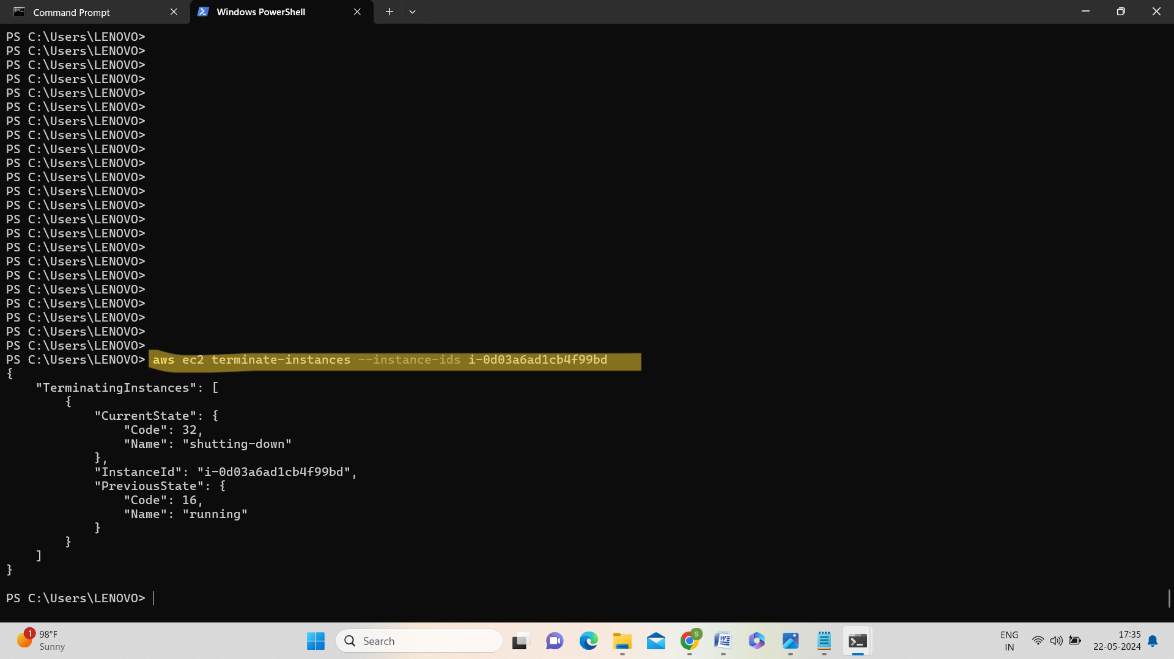

* We should paste the instance id which we are going to terminate.